Project Planning Phase
Project Planning Template (Product Backlog, Sprint Planning, Stories, Story points)
Date | 30 September 2026
Team ID | SWTID-2026-4970
Project Name | Import Data using Transform Maps (Spreadsheet)
Maximum Marks | 5 Marks
Product Backlog, Sprint Schedule, and Estimation (4 Marks) Use the below template to create product backlog and sprint schedule
Sprint | Functional  Requirement (Epic) | User Story Number | User Story / Task | Story Points | Priority | Team Members
Sprint-1 | Data Preparation | USN-1 | As a user, I can create a Google Spreadsheet with sample employee data (Employee ID, Name, Email, Department, Location). | 1 | High | [Team member]
Sprint-1 |  | USN-2 | As a user, I can download the spreadsheet as Sample Spreadsheet.xlsx. | 1 | High | [Team member]
Sprint-1 | Custom Table | USN-3 | As an admin, I can create the custom table Employee Test (u_employee_test). | 2 | High | [Team member]
Sprint-1 |  | USN-4 | As an admin, I can add the fields Employee ID, Employee Name, Email, Department and Location (String) using Form Layout. | 2 | High | [Team member]
Sprint-1 | Import Set | USN-5 | As an admin, I can load the Excel file using Load Data into the staging table Employee Import (u_employee_import). | 2 | High | [Team member]
Sprint-1 | Transform Map | USN-6 | As an admin, I can create the Transform Map Sample Spreadsheet Import and map source fields to target fields using Auto Map Matching Fields / Mapping Assist. | 3 | High | [Team member]
Sprint-1 |  | USN-7 | As an admin, I can run the Transform and validate that all 15 records are created in the Employee Test table. | 3 | High | [Team member]
Sprint-2 | Coalesce | USN-8 | As an admin, I can enable Coalesce on the Employee ID field to avoid duplicate records. | 2 | High | [Team member]
Sprint | Functional  Requirement (Epic) | User Story Number | User Story / Task | Story Points | Priority | Team Members
Sprint-2 |  | USN-9 | As an admin, I can import the updated Excel data and verify 2 inserts and 2 updates in Transform History. | 3 | High | [Team member]
Sprint-2 |  | USN-10 | As an admin, I can re-import the same file and verify that all 4 rows are ignored (no duplicates). | 1 | Medium | [Team member]
Sprint-2 | Reports | USN-11 | As an HR user, I can view the report Employees by Department (Pie chart, Count). | 2 | Medium | [Team member]
Sprint-2 |  | USN-12 | As an HR user, I can view the report Employees by Location (Bar chart, Count). | 2 | Medium | [Team member]
Sprint-2 |  | USN-13 | As an HR user, I can view the Employee List Report (List with all 5 columns). | 2 | Medium | [Team member]
Sprint-2 | Dashboard | USN-14 | As an admin, I can set Admin Overrides to true in the pa_dashboards ACL and create the Employee Analytics Dashboard. | 3 | Medium | [Team member]
Sprint-2 |  | USN-15 | As an admin, I can add all 3 reports to the dashboard and share it with users, groups and roles. | 3 | Medium | [Team member]
Total Story Points = 14 (Sprint-1) + 18 (Sprint-2) = 32
Project Tracker, Velocity & Burndown Chart: (4 Marks)
Sprint | Total Story Points | Duration | Sprint Start Date | Sprint End Date (Planned) | Story Points Completed  (as on Planned End  Date) | Sprint Release Date (Actual)
Sprint-1 | 14 | 6 Days | 19 Jan 2026 | 24 Jan 2026 | 14 | 24 Jan 2026
Sprint-2 | 18 | 6 Days | 26 Jan 2026 | 31 Jan 2026 | 18 | 31 Jan 2026
Velocity:
Total story points completed = 14 + 18 = 32 across 2 sprints, so the team velocity is 32 / 2 = 16 story points per sprint.
Each sprint lasts 6 days, so the average velocity (AV) per iteration unit (story points per day) is:
AV = velocity / sprint duration = 16 / 6 ≈ 2.67 story points per day
Burndown Chart:
A burn down chart is a graphical representation of work left to do versus time. It is often used in agile software development methodologies such as Scrum. However, burn down charts can be applied to any project containing measurable progress over time.
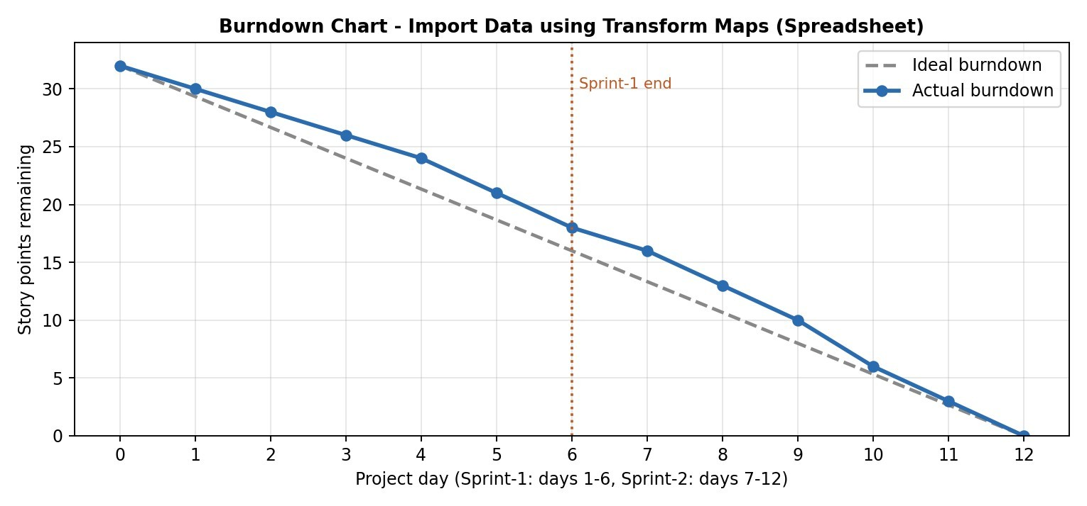
The chart shows 32 story points remaining at the start, falling to 18 at the end of Sprint-1 and to 0 at the end of Sprint-2, closely following the ideal line.
https://www.visual-paradigm.com/scrum/scrum-burndown-chart/ https://www.atlassian.com/agile/tutorials/burndown-charts Reference:
https://www.atlassian.com/agile/project-management https://www.atlassian.com/agile/tutorials/how-to-do-scrum-with-jira-software https://www.atlassian.com/agile/tutorials/epics https://www.atlassian.com/agile/tutorials/sprints https://www.atlassian.com/agile/project-management/estimation https://www.atlassian.com/agile/tutorials/burndown-charts

